A 1% rally on Friday rescued a losing week, pushing U.S. markets into positive territory for the week. The Dow closed the week up 0.60% at 18,543.53 and the S&P 500 gained 0.43% to close at 2,182.87.
The likely reason for the late week rally was the labor department reporting the U.S. economy added 255,000 jobs in July, well above the expected 180,000. The strong July jobs report sent Treasury yields higher and made a December Federal Reserve (Fed) rate hike more likely. The unemployment rate remained unchanged at 4.9 percent.
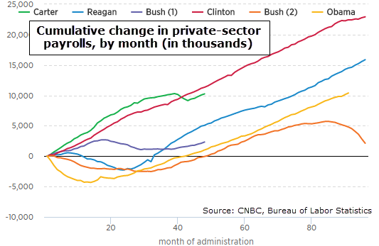
Finally, “jobs” are a constant topic on the campaign trail this year. The Republicans decry what they view as Obama’s dismal job-creation record, while Democrats counter with claims that jobs created during Obama’s term are actually stellar. Here (below) is a chart of jobs created since the start of each recent President’s term, going back to Jimmy Carter. Both sides can take some comfort: Obama comes in well below Clinton and Reagan, but better than George W. Bush (who was saddled with both the 2000-2002 recession and the 2007 employment turndown).

A major concern is volatility as we approach the presidential election. According to EPFR Global data, investors have pulled money from U.S. equities in the month before Election Day for the past four presidential elections. Historically, this uncertainty increases if a new party is anticipated to take over.
Most of the major indexes reached new highs over the past week, but technical indicators point to overbought conditions. This week we will be closely watching a number of key economic events, including jobless claims on August 11th and retail sales on August 12th.
Regards,
Jeremiah Patterson, CFP®
Copelin Financial Advisors
514 Brooks Street
Sugar Land, TX 77478
Phone: 281 240-2902
Fax: 281 240-2856
jeremiah@copelinfinancial.com
Securities offered through ProEquities, Inc., a Registered Broker-Dealer and Member FINRA & SIPC Advisory Services offered through Harvest Investment Services, LLC., a Registered Investment Advisor Copelin Financial Advisors, Inc and Harvest Investment Services, LLC are independent of ProEquities, Inc.

